Image merge

**[Testing Image]**

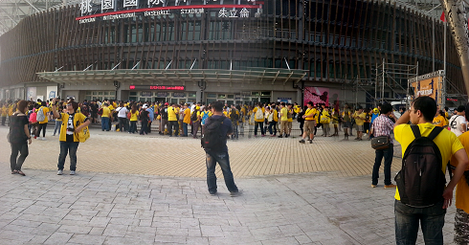

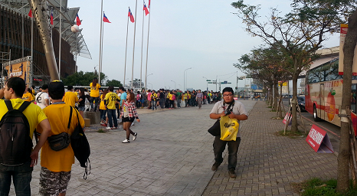

Fig1. two photos

I have chosen two pictures that I took as samples. The scene was taken when I went to the baseball contest (shown as Figure 1), and I want to merge two pictures together.

**[Result]**

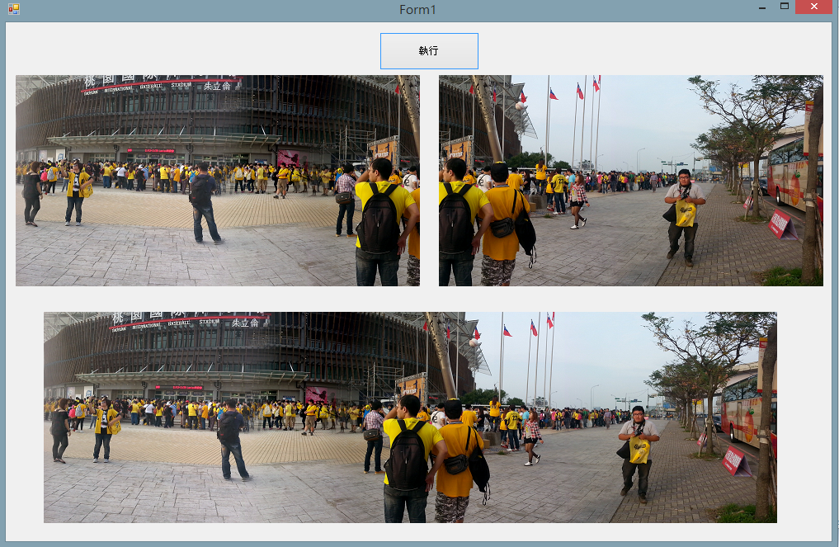

Fig2. Output

Figure 2 is the result. The top-left one is the left-sided image, and the top-right image is the right-sided image. The image at the bottom is the merged output that has been processed.

**[Processing& Code]**

1st step→get pixel of two photos, and save to rgbDataleft and rgbDataright.

[C# code]

public int[, ,] getRGBData(Image image)

{

// Step 1: 利用 Bitmap 將 image 包起來

Bitmap bimage = new Bitmap(image);

int Height = bimage.Height;

int Width = bimage.Width;

int[, ,] rgbData = new int[Width, Height, 3];

// Step 2: 取得像點顏色資訊

for (int y = 0; y < Height; y++)

{

for (int x = 0; x < Width; x++)

{

Color color = bimage.GetPixel(x, y);

rgbData[x, y, 0] = color.R;

rgbData[x, y, 1] = color.G;

rgbData[x, y, 2] = color.B;

}

}

return rgbData;

}

2nd step→transformation of coordinates。

(x’,y’)=(x,y)

(x’,y’)=(0,423) ,(1,423) ,(2,423)

(x,y)=(0,0) ,(1,0) ,(3,0)  
y’=y+423

3rd step→Image overlay。

[C# code]

left=Image.FromFile(".../image/left.png");

right=Image.FromFile(".../image/right.png");

pictureBox2.Image=left;

pictureBox3.Image=right;

int[, ,] rgbDataleft = getRGBData(left);

int[, ,] rgbDataright = getRGBData(right);

int[, ,] rgbData = new int[889, 256, 3]; ;

image = new Bitmap(889, 256);

int Width = image.Width;

int Height = image.Height;

for (int y = 0; y < Height; y++)

{

for (int x = 0; x < Width; x++)

{

if(x<423){

rgbData[x, y, 0] = rgbDataleft[x, y, 0];

rgbData[x, y, 1] = rgbDataleft[x, y, 1];

rgbData[x, y, 2] = rgbDataleft[x, y, 2];

image.SetPixel(x, y, Color.FromArgb( rgbData[x, y, 0] , rgbData[x, y, 1] , rgbData[x, y, 2] ));

}

else if (x >= 423)

{

rgbData[x, y, 0]=rgbDataright[(x-423),y,0];

rgbData[x, y, 1] = rgbDataright[(x - 423), y,1];

rgbData[x, y, 2] = rgbDataright[(x - 423), y, 2];

image.SetPixel(x, y, Color.FromArgb( rgbData[x, y, 0] , rgbData[x, y, 1] , rgbData[x, y, 2] ));

}

}

}

pictureBox1.Image=image;